1. **Introduction**

**Project Title :** Town View

**Project Members :**

1. SHAHADATH HOSSAIN RAKIB 19-39358-1
2. ESHRAT JAHAN HOQUE 19-39392-1
3. MD. ARIYAN JAHANGIR 19-40259-1
4. TANZINA AZMARIN SHARNA 19-40322-1
5. **Background**

Town View captures the scenic atmosphere of a town in a day to day basis. Cars driving through the roads, small to medium sized buildings standing beside the roads, cloudy environment with a possibility of rain sometimes, organized rows of trees, traffic signal, night life, etcetera. So, Summarized,

The project will have 3 modes.

- Day/Sunny Mode

- Rainy Mode

- Night Mode

There will be moving clouds and moving cars on the road. The movement of the cars can be changed according to traffic signal. Rain will come down from the clouds when rainy mode is activated and lights will switch on in houses and cars when night mode is activated.

1. **Methodology**

- Background :

For all the background objects ( Road, Road Lines, Border, Buildings , Sky , Clouds ) we have used GL_QUADS and as for data type we have chosen double instead of float for easier calculation of position. We have used glColor3ub() function to add colours to our objects.  
For Stars, we have used GL_POINTS and used an algorithm to draw points which look like stars in different position of the sky using the RAND function.  
For Moon, we have used GL_TRIANGLE_FAN and constructed a function that will draw circle. We have used this function also for the traffic lights.

We have drawn buildings in such a way that the windows and glass doors will be able to change colour ( turn on light in night mode ). For this we have taken variables for setting colours.

-Cars:

We have used GL_QUADS to draw the cars and in order to move them we have used the glTranslated() function and used a variable inside it so that we can modify the speed of the cars. To Modify the speed of cars, we have used the glutTimerFunc() function to call the update function simultaneously and in the function we modified the speed by using mouse event handler

-Traffic Lights:

We have used GL_QUADS to draw the outline and used the circle drawing function we made for moon and drew the lights. We enabled mouse response on the lights and connected it with the Car speed so, whenever the lights are clicked with the mouse the car speed got modified accordingly.

-Clouds:

We have used the glTranslated() function to move the clouds and glScaled() function to resize the clouds when we didn’t want those to be seen. We have Done the same for Moon and stars.

- Day/Night/Rain:

We have used glutKeyboardFunc() function to add features of pressing various buttons to change the day/night/rain cycle. Because of this we had to change the background shading using variables.

-Sound Effects:

We have added sound effects in our project using PlaySound() function and all the sound files are saved in the project debug folder.

1. **Significance Of The Project**

By doing this project, We are learning to draw objects , to move,to make the object bigger & smaller.Learning to draw circles without using any pre-defined function.Learning to use the handler function to take input from mouse & keyboard.This will help us in the future **“OpenGL”** projects.It will help us in the Game development . We will also be able to make games with **“OpenGL”.**

1. **Conclusion**

Our project topic is Town view and we successfully completed 98% of the topic. We couldn’t manage to apply rain effect but rest of the functionalities were properly implemented. We found out that OpenGL doesn’t support simultaneous playing of multiple sound track and extra audio library is required to do so. That’s why we couldn’t play multiple sound at once. We have 3 modes available and various movement functionality of car. We used the concept of translation and scaling based on our learnings.

Bindings

Press ‘R’ - Rainy Mode

Press ‘S’ - Sunny/Day Mode

Press ‘N’ - Night Mode

Mouse Left Click on Traffic ( Red ) - Stop Cars

Mouse Left Click on Traffic ( Yellow ) - Slow Cars

Mouse Left Click on Traffic ( Green ) - Regular Speed of Cars

1. **Screen-Shot Of The System**

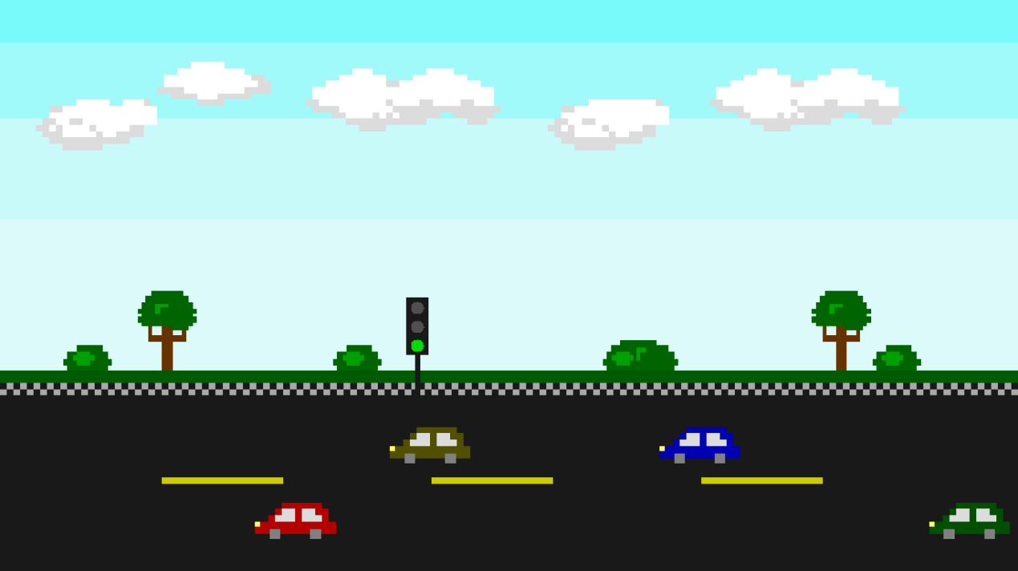

**Screenshot 1 ( WIP - Day Mode)**

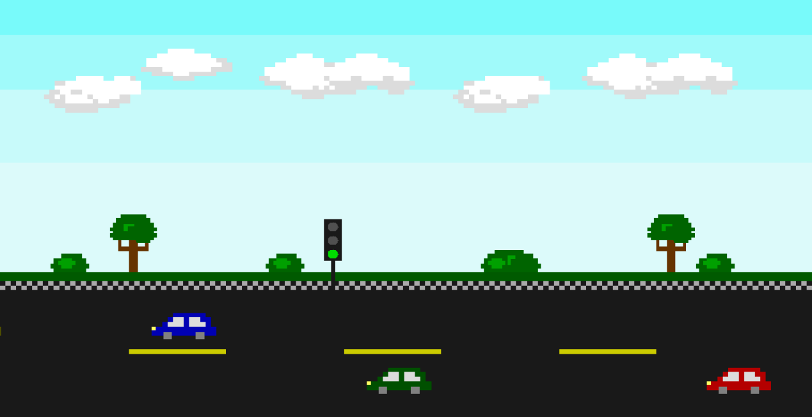

**Screenshot 2 ( WIP - Cars Moving )**

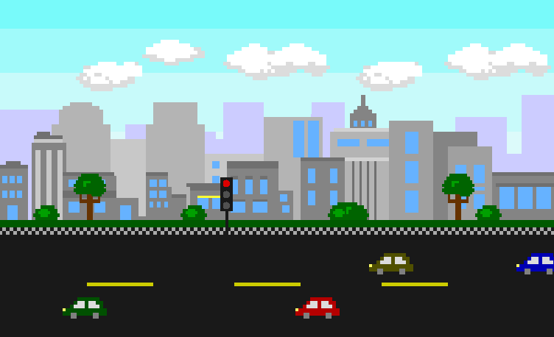

**Screenshot 3 ( Red Signal )**

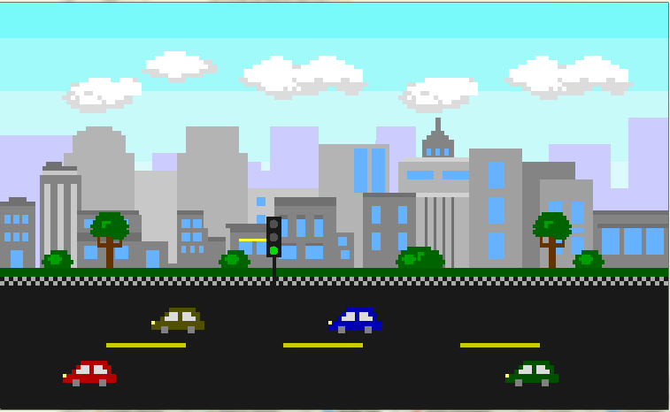

**Screenshot 4 ( Green Signal )**

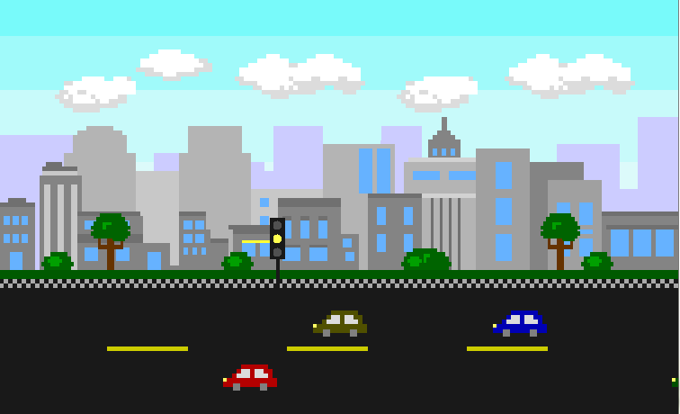

**Screenshot 5 ( Yellow Signal )**

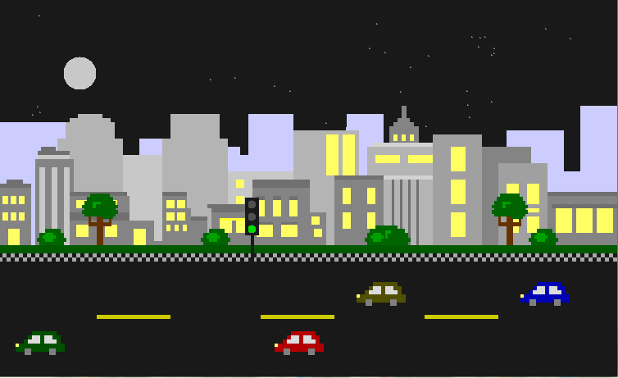

**Screenshot 6 ( Night Mode )**

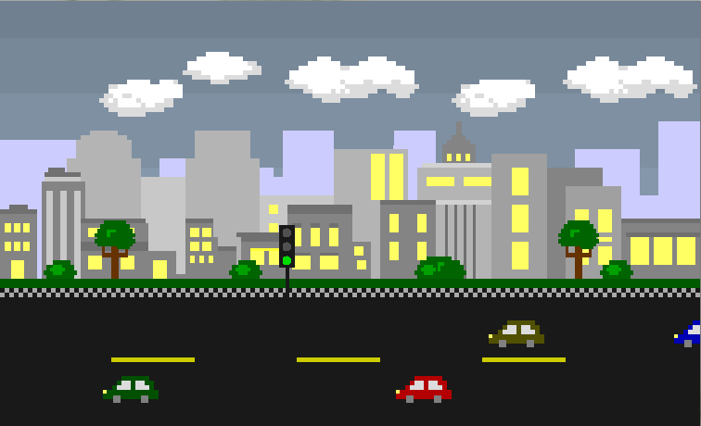

**Screenshot 7 ( Rainy Mode )**